

**Department of**

**Computer Science and Engineering**

**Lab Report - 08**

Course No. : CSE-308

Course Title : System Analysis and Design Laboratory

Submitted By :

Name : 1 . Tasmim Sultana(129)

2 . Fatama Jannat Tisha (131)

3 . Kamelia Zaman Moon (299)

4 .Umma Salma (302)

5 . Sabrina Afrin Toma (304)

Session : 2017-18

Semester : 3rd year 1st Semester

Date : 18-4-2021

Submitted To :

Md Musfique Anwar

Associate Professor , Department of Computer Science and Engineering

Dr. Md Humayun Kabir

Professor , Department of Computer Science and Engineering

Jahangirnagar University, Savar

**Experiment No.:** 08

**Title:** Data Processing Subsystem & Management Information System

**Objective:** To get an idea about how the Management Information System(MIS) obtains data from the Data Processing Subsystem. To identify subsystem databases. To identify subsystems and modules.

**Procedure:**

1. We determine which are the subsystem and processing systems for our project.

2. We determine which the modules are.

3. Then we connect processes to the modules.

**Diagram**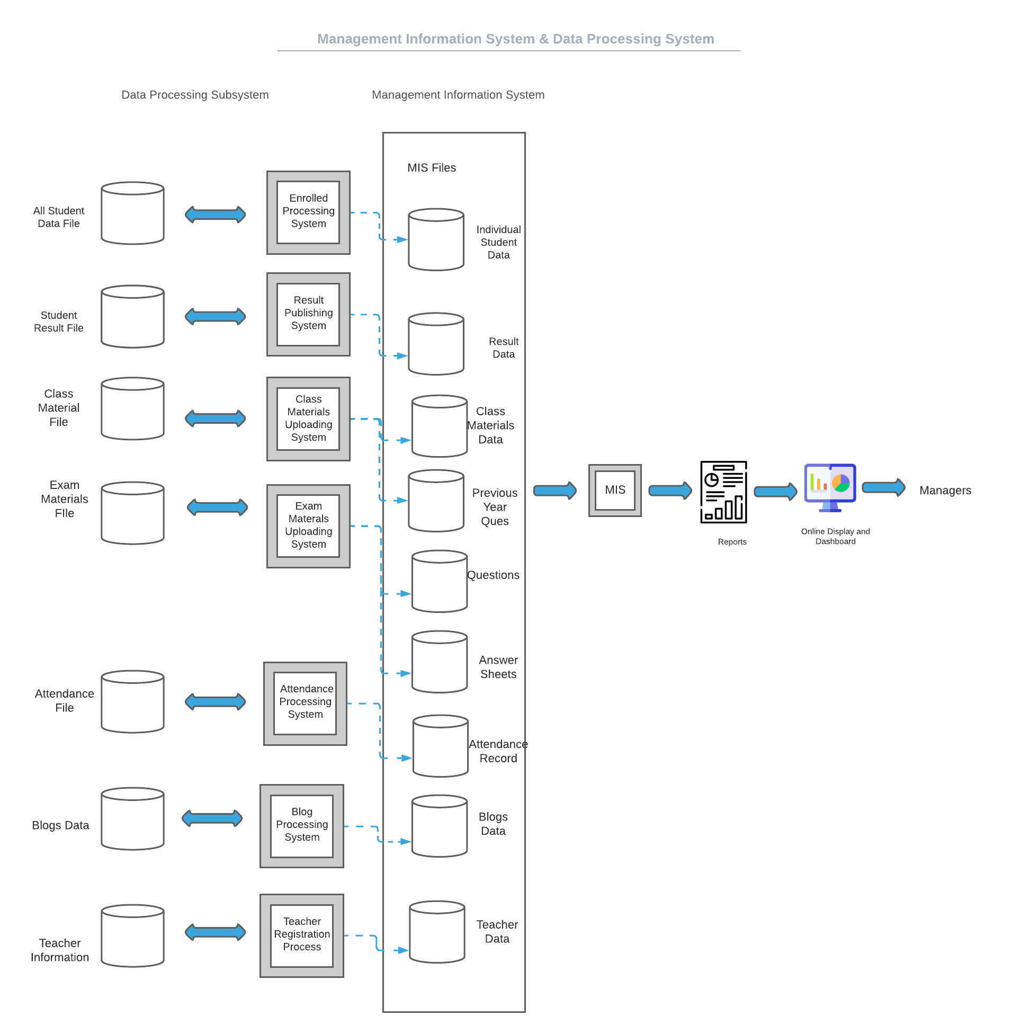

**Discussion:** In TPS, the collection, the process, and the store transaction occur in a single day is calculated. This system is very beneficial for a company to keep track of the total number of canceled orders as well as the sales the company made on a specific date. A Management Information System (MIS) is a computerized information-processing system designed to support the activities of company or organizational management. MIS process, store, retrieve, and analyze data collected for the administrative purposes.